PROJECT DOCUMENTATION PHASE
Title: Visitor management system
1.INTRODUCTION
The Visitor Management System is a custom application developed on the ServiceNow Zurich platform to simplify and automate the process of visitor registration and tracking within an organization. In many organizations, visitor information is often recorded manually using paper registers or spreadsheets, which can lead to errors, data loss, security issues, and difficulty in tracking visitor activities. To overcome these challenges, the Visitor Management System provides a centralized and digital solution for managing visitor records efficiently.

This application enables employees or reception staff to register visitor details such as visitor name, phone number, email address, company name, person to visit, purpose of visit, and visit date. The system stores all visitor information in a custom ServiceNow table, making it easy to access, manage, and monitor visitor records whenever required. The application also includes a phone number validation mechanism using Client Scripts to ensure that only valid phone numbers are entered into the system.

To improve security and communication, the application uses ServiceNow Flow Designer to automatically send email notifications to the security team whenever a new visitor is registered. This helps the security department stay informed about expected visitors and prepare for their arrival. In addition, a custom UI Action called "Check In" is provided to allow security personnel or reception staff to update the visitor's status when the visitor arrives at the organization.

The Visitor Management System demonstrates the use of key ServiceNow development components such as custom tables, form design, client scripts, Flow Designer, email notifications, and UI Actions. By automating visitor registration and check-in processes, the application reduces manual effort, improves data accuracy, enhances security management, and provides a better experience for both employees and visitors.

Overall, the Visitor Management System is an efficient, secure, and user-friendly solution that showcases the capabilities of the ServiceNow platform in developing real-world business applications and workflow automation systems.

2. Project Objectives
Content:
- Register visitor details.
- Store visitor information.
- Validate visitor phone numbers.
- Notify security team automatically.
- Track visitor check-in status

3. System Requirements
Content:

Requirement | Details
Platform | ServiceNow Zurich
Instance Type | Developer Instance
Tool | App Engine Studio
Workflow Tool | Flow Designer
Database | ServiceNow Tables
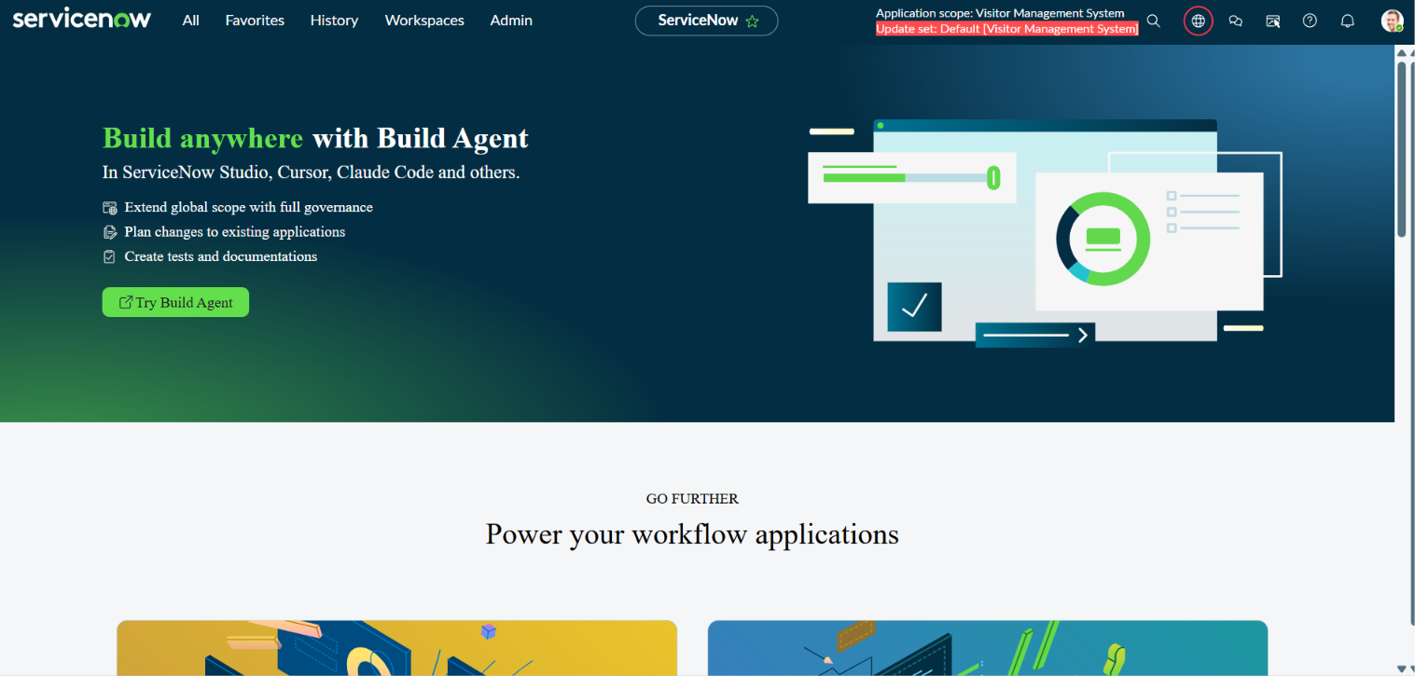

4. Application Creation
Step 1: Create Application
Content
- Open App Engine Studio.
- Click Create App.
- Select Start From Scratch.
- Enter Name as Visitor Management System.
- Click Create.
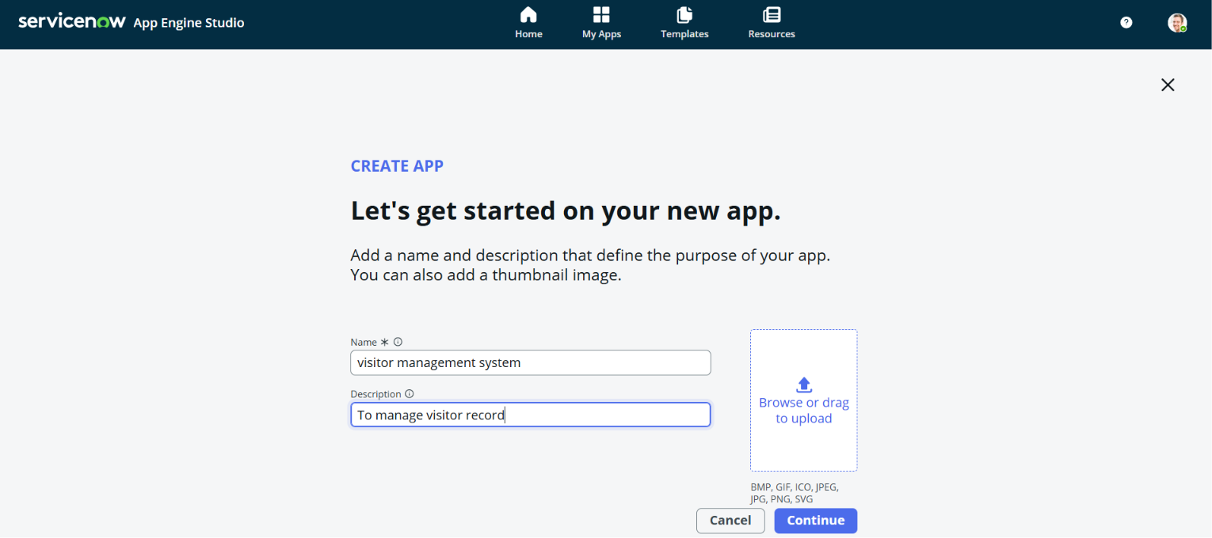

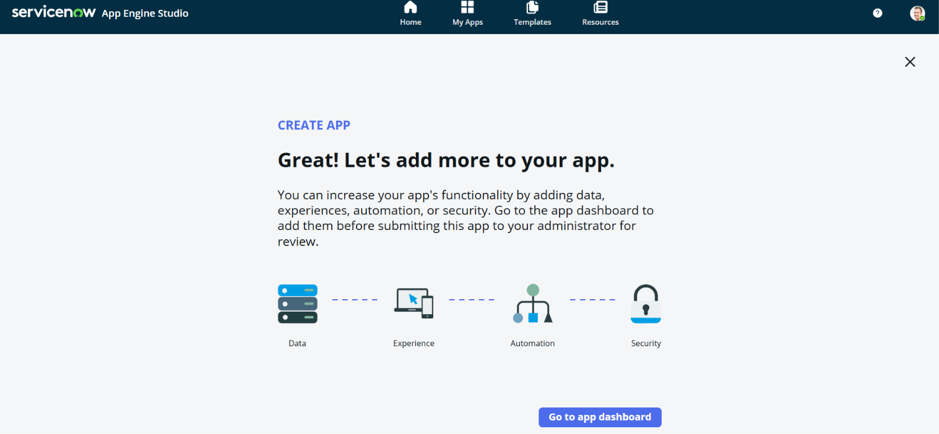

5. Table Creation
Step 2: Create Visitor Table
Content
Explain:
Created custom Visitor table to store visitor information.
Steps Performed:
1. Opened the Visitor Management System application.
2. Selected Data from App Engine Studio.
3. Clicked Add → Create a Blank Table.
4. Entered the table label as Visitor.
5. Enabled Auto Number generation.
6. Configured the numbering format with prefix VIS.
7. Created the table.
8. Added the following fields:

- Visitor Name
- Phone Number
- Email
- Company
- Person To Visit
- Visit Date
- Purpose
- Status

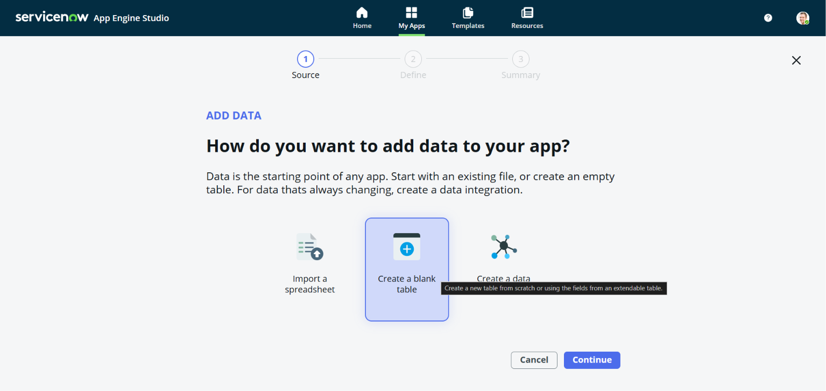
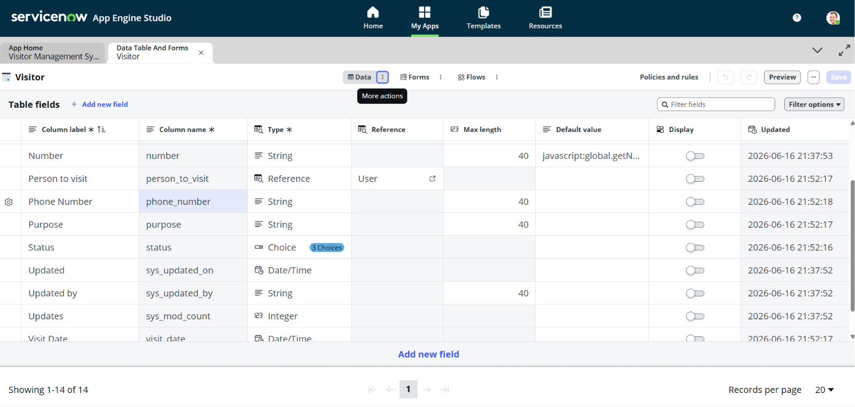

6. Form Design
Step 3: Configure Form Layout
Content:
Configured form layout to display visitor fields.
Steps Performed:
1. Opened the Visitor table.
2. Accessed Form Layout configuration.
3. Added all visitor-related fields.
4. Arranged the fields in a logical order.
5. Saved the form layout.

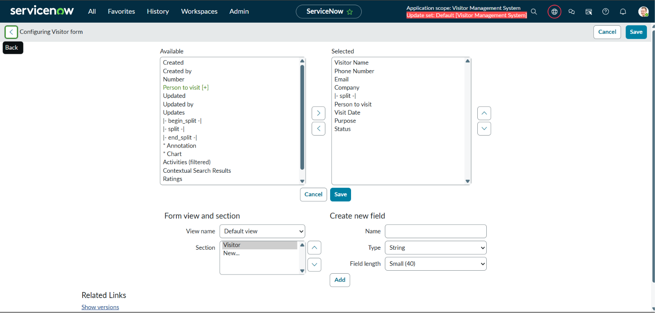

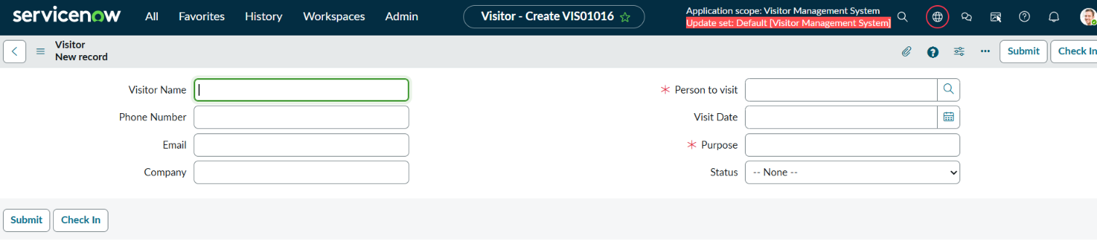
7. Client Script Implementation
Step 4: Phone Number Validation
Content:
Created Client Script to validate 10-digit phone numbers.
Validation Rule:
- Only numbers allowed
- Exactly 10 digits
Steps Performed:

1. Navigated to System Definition → Client Scripts.
2. Clicked New.
3. Selected the Visitor table.
4. Chose Client Script Type as onSubmit.
5. Entered the validation script.
6. Added a regular expression to validate 10-digit phone numbers.
7. Saved and activated the Client Script.

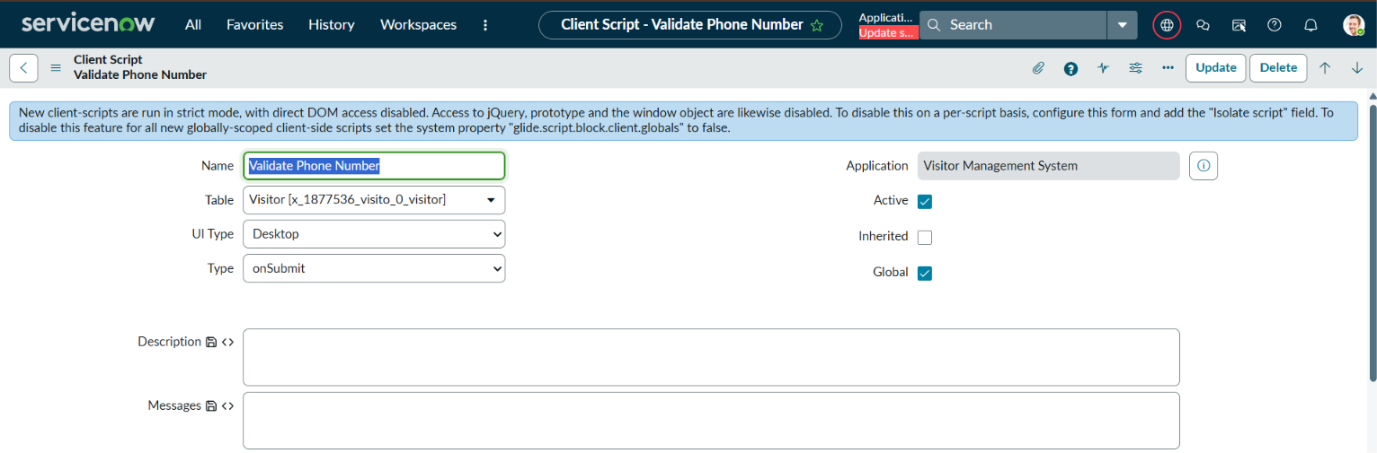

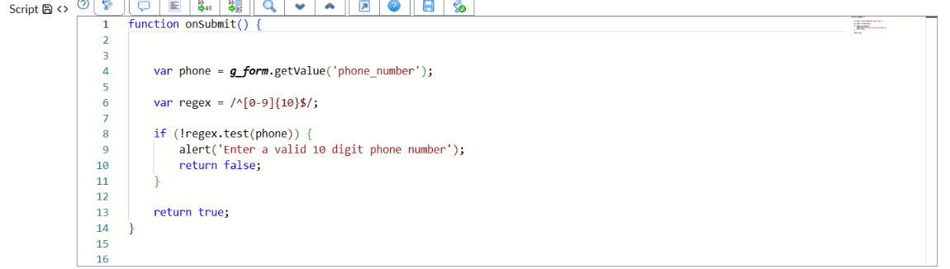

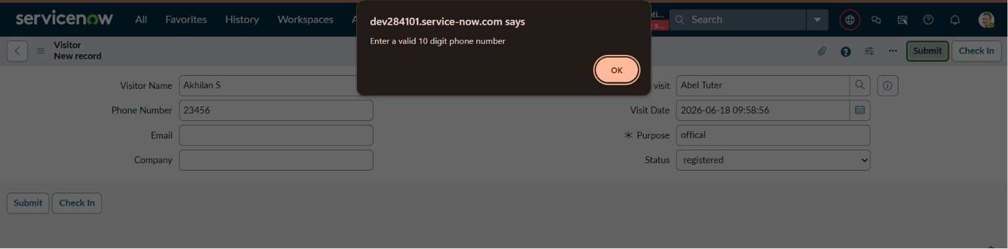

8. User Creation
Step 5: Security User Creation
Content:
Created Security Team user to receive visitor notifications.
Steps Performed:
1. Navigated to User Administration → Users.
2. Clicked New.
3. Entered the user name as Security Team.
4. Entered the email address.
5. Saved the user record.
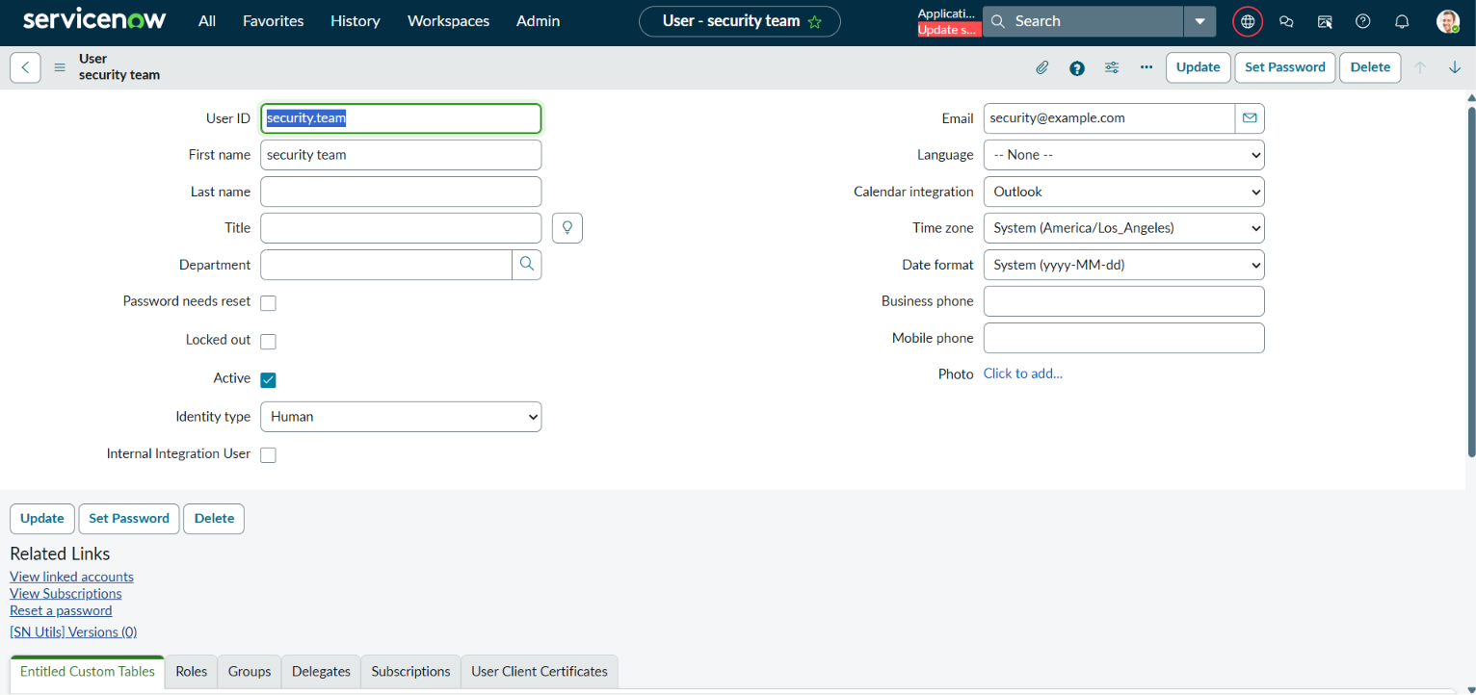

9. Flow Designer
Step 6: Create Flow
Content:
Created flow to send email notifications whenever a visitor record is created.

Steps Performed:
1. Opened Flow Designer.
2. Clicked New Flow.
3. Entered the flow name as Visitor Registration Notification.
4. Created a Record Trigger.
5. Selected Visitor table.
6. Configured trigger condition as Record Created.
7. Added Send Email action.
8. Configured recipient as Security Team.
9. Added visitor details in the email body.
10. Saved and activated the flow.

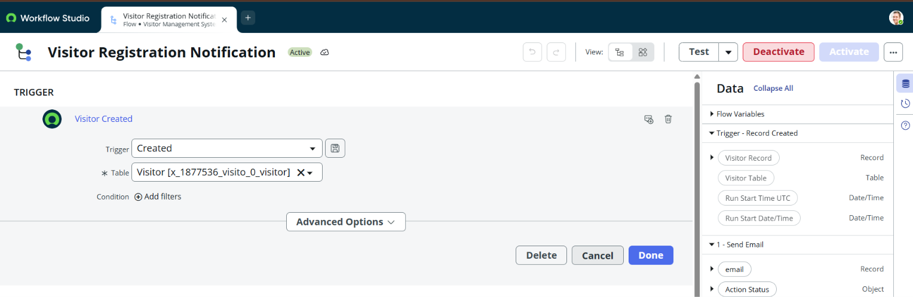
Email Action
Configured Send Email action.
Recipient:
Security Team

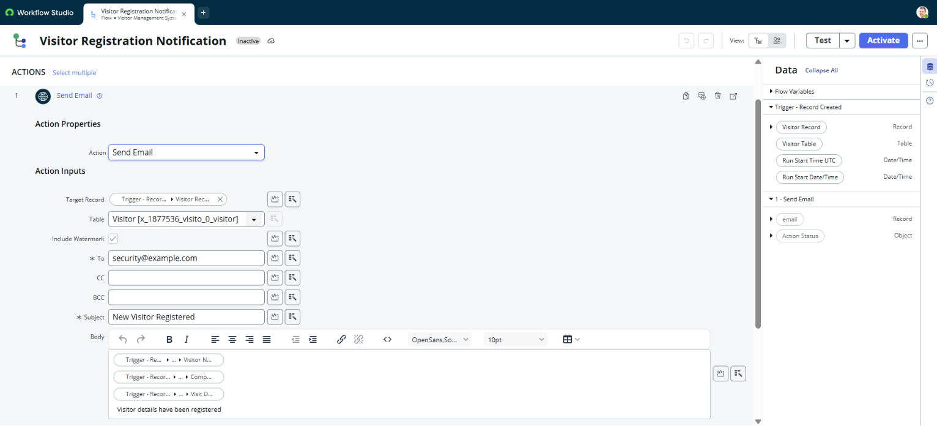

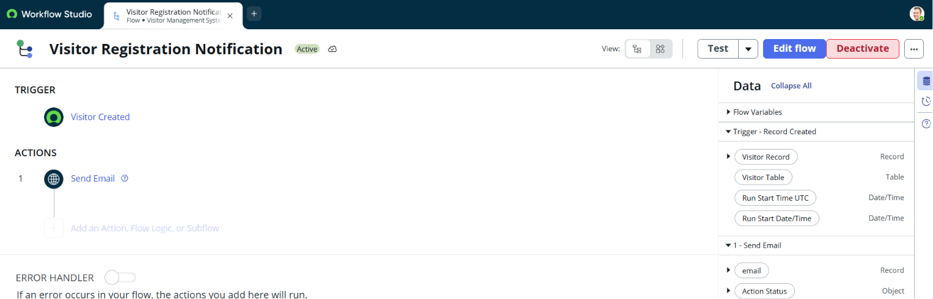

Flow Activated:
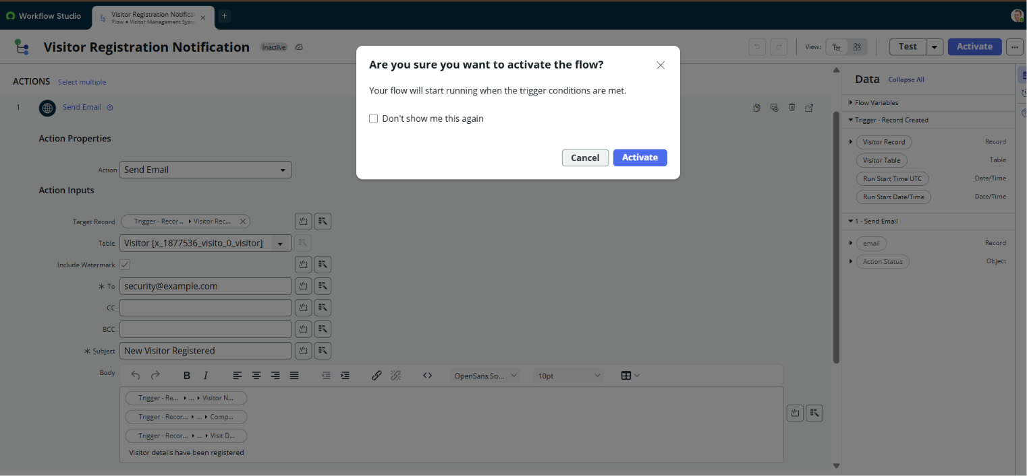
10. UI Action
Step 7: Create Check In Button
Content:
Created UI Action to update visitor status.
Button Name:
Check In
Function:
Changes Status from Registered to Checked In.
Steps Performed:
1. Navigated to System Definition → UI Actions.
2. Clicked New.
3. Entered the name as Check In.
4. Selected the Visitor table.
5. Enabled Form Button.
6. Added script to update the visitor status.
7. Saved the UI Action.
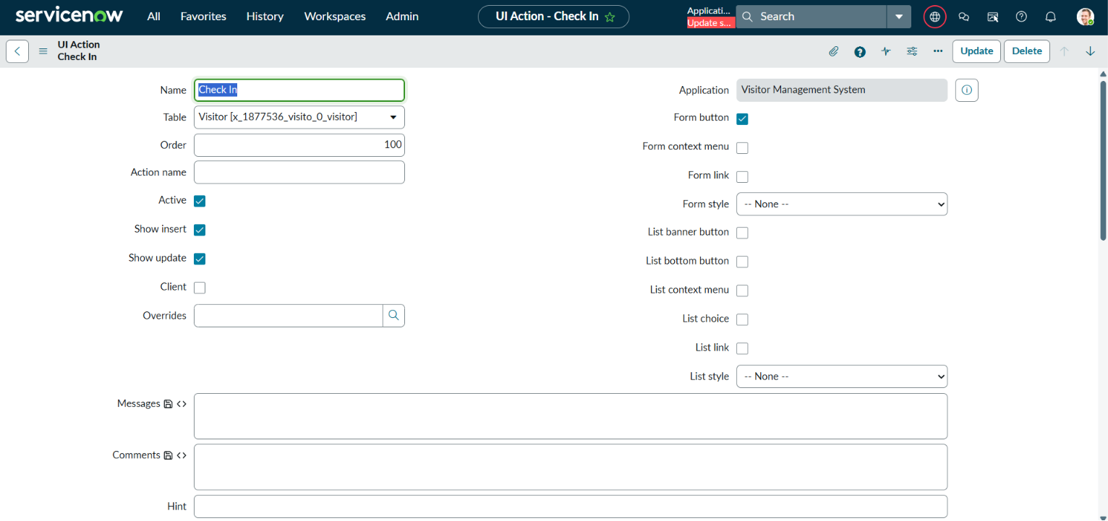

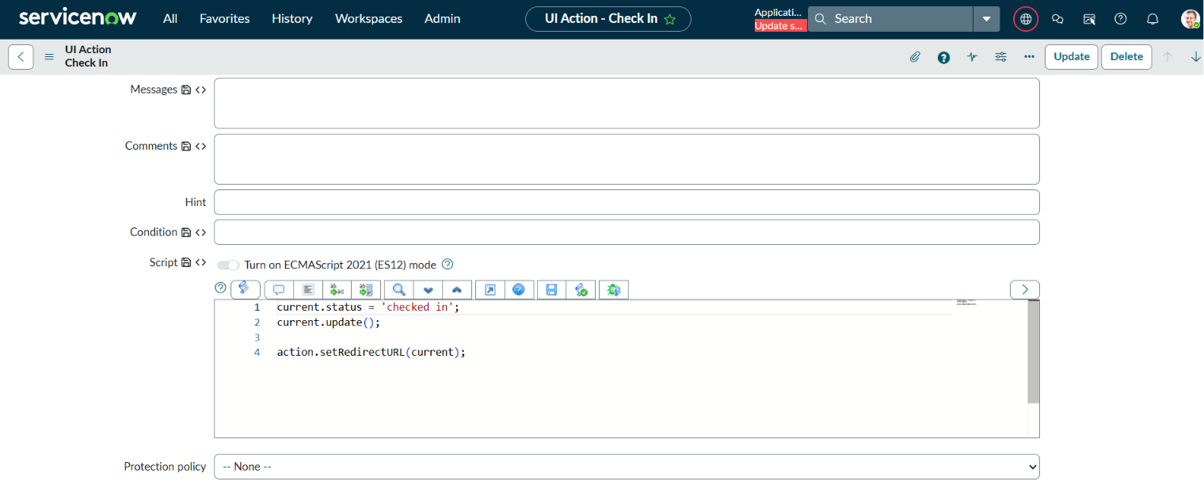

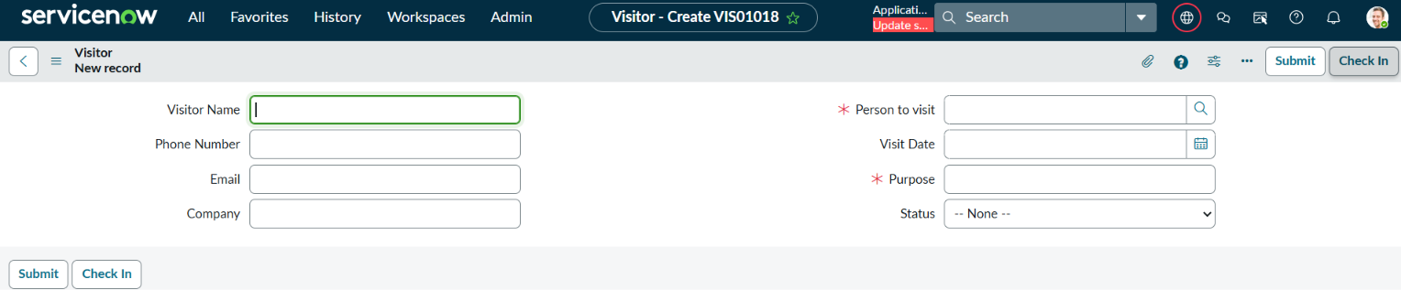
11. Testing
Test Case 1
Visitor Registration
Input:
- Visitor Name
- Phone Number
- Company
- Visit Date
Expected Result:
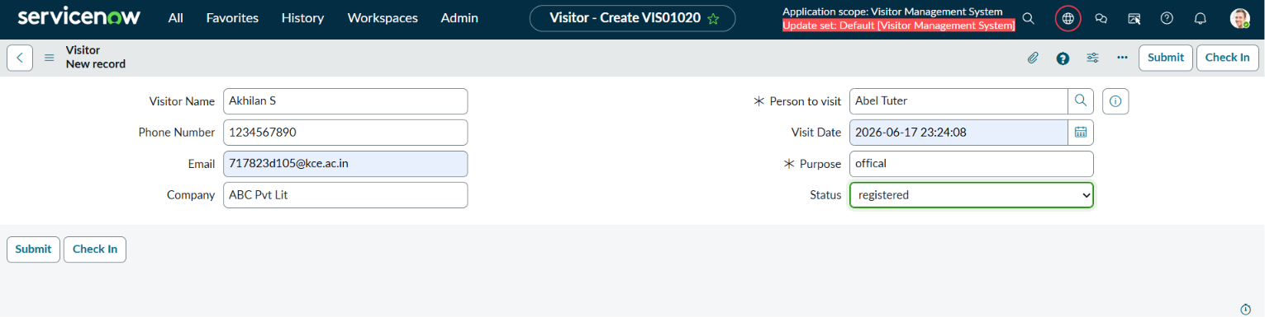
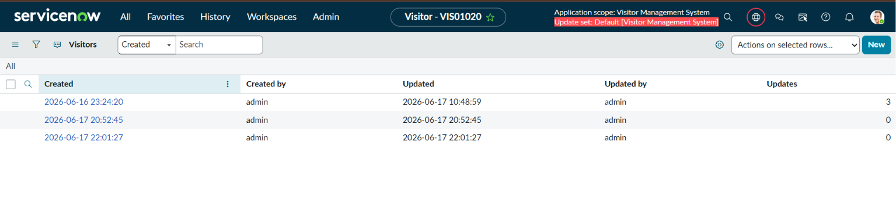
Test Case 2
Phone Validation
Input:
Invalid Phone Number
Expected Result:
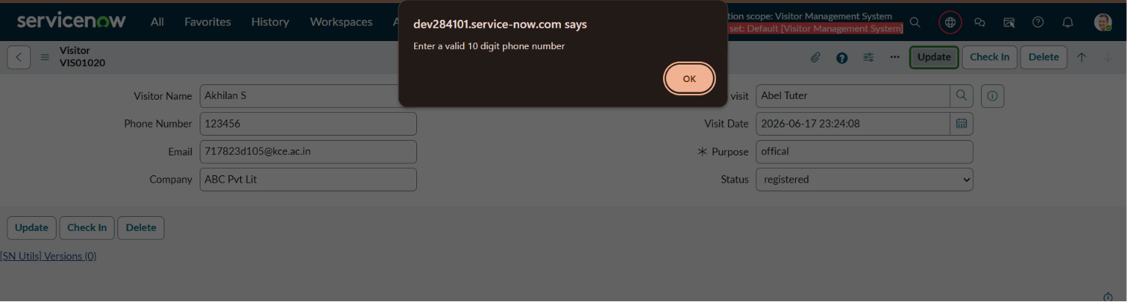
Test Case 3
Email Notification
Expected Result:
Security receives email.
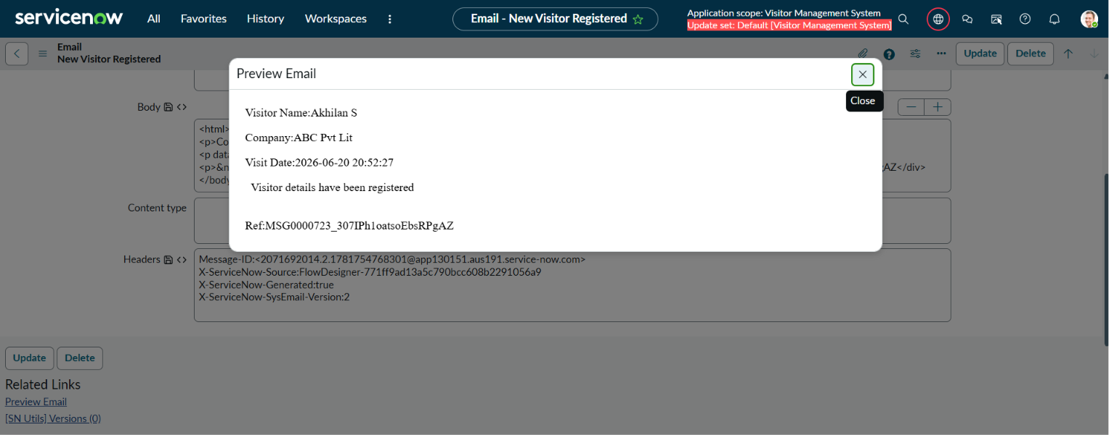
Test Case 4
Visitor Check In
Expected Result:
Status changes to Checked In.
Before Check In:
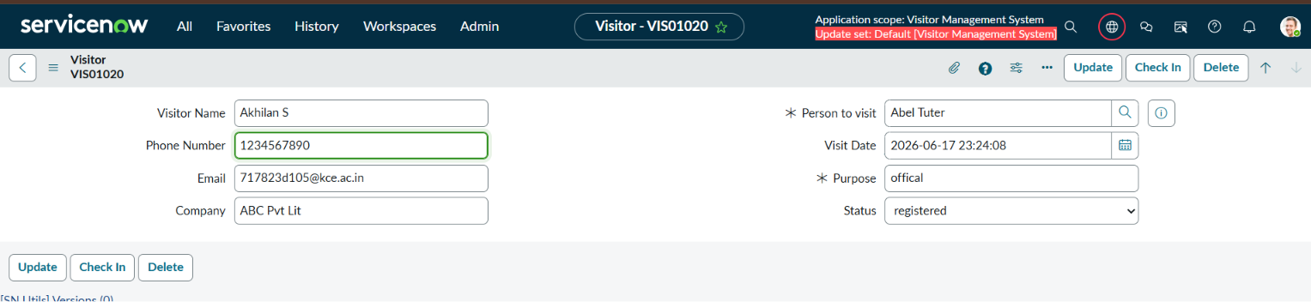
After Check In:
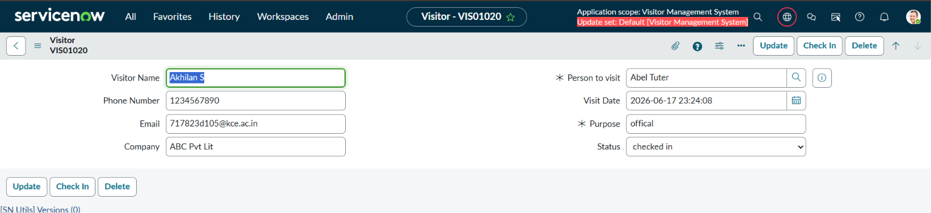

12. Results
Content:
The Visitor Management System was successfully developed using ServiceNow Zurich.
Features Implemented:
✔ Visitor Registration
✔ Custom Visitor Table
✔ Phone Number Validation
✔ Email Notification
✔ Security Notification
✔ Check In Button
✔ Status Tracking
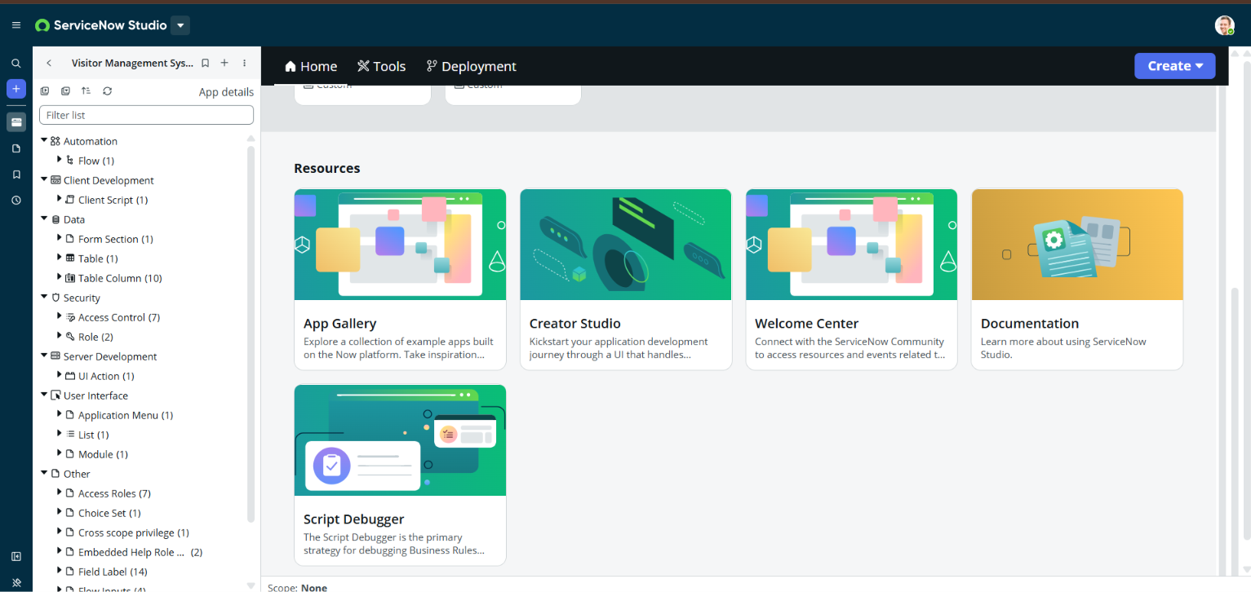

13. Conclusion
Content:
The Visitor Management System successfully automates visitor registration and tracking. It reduces manual work, improves security communication, and provides a centralized platform for visitor management.

